Another Day in Paradise
by Phil Collins

She calls out to the man on the street
"Sir, can you help me?
It's cold and I've nowhere to sleep,
Is there somewhere you can tell me?"

He walks on, doesn't look back
He pretends he can't hear her
Starts to whistle as he crosses the street
Seems embarrassed to be there

Oh think twice, it's another day for
You and me in paradise
Oh think twice, it's just another day for you,
You and me in paradise

She calls out to the man on the street
He can see she's been crying
She's got blisters on the soles of her feet
Can't walk but she's trying

Oh think twice...

Oh lord, is there nothing more anybody can do
Oh lord, there must be something you can say

You can tell from the lines on her face
You can see that she's been there
Probably been moved on from every place
'Cos she didn't fit in there

Oh think twice...

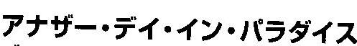
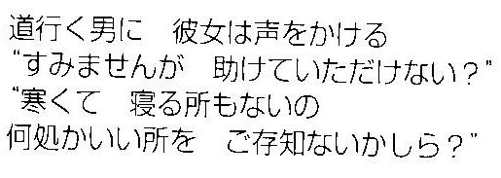
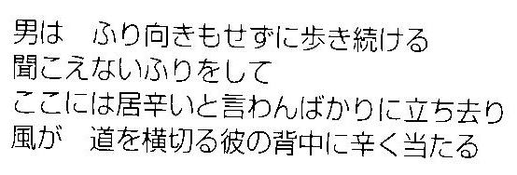

もう一回考えてごらん
何不自由ない楽園の様なこの世の一日なのに。。。
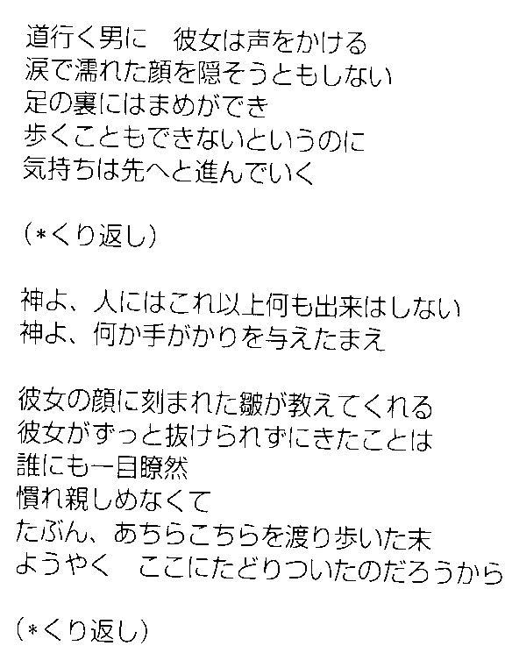

Vocabulary
Find these expressions in the English lyrics (歌詞). Then look at the Japanese translation, find the Japanese expressions and write it next to expression below:
- Paradise 6. Lines on (his/her/your/…) face
- Pretend 7. You can tell(from---that---)
- Embarrassed 8. (I’ve/You’ve/She’s/…)(really)been there.
- Think twice. 9. (Be) moved on
- Blister 10. Fit in (somewhere)
Speaking Topics
1. This song is about helping people who are weaker than us. Have you ever volunteered? (for example, visiting someone who is sick or old, helping someone who needs your help.) It can be yourself or with a class. Tell me about the experience. How was it? How did the person/people you helped react? What did you learn from the experience?
2. Imagine you are walking near a public station and you hear your name being called. You turn around and you see that an old friend, someone you used to know, has become homeless! Tell the story about what happens after that.
3. Imagine you wake up one night to find yourself lying on the street near a public station. You are wearing dirty old clothes. You realize that you are homeless! Tell the story about what happens after that.
Background Jesus on helping the poor and needy:
Jesus said:
I was hungry and you gave me food
I was thirsty and you gave me drink
I was a stranger and you welcomed me
I was naked and you clothed me
I was sick and you visited me
I was in prison and you came to me.
And they said: “Lord, when did we do these things?
Jesus said:
Truly, I say to you, as you did it to the least of my brothers, you did it to me.
(the least = the poorest, weakest, most helpless people (for example, homeless people)

